

PREDICTIVE MODEL FORFAKE NEWS DETECTION USING NLP : PROBLEM UNDERSTANDING AND DESIGN APPROACH

Problem Definition:

In an age where information dissemination is swift and ubiquitous, the proliferation of fake news has become a significant societal concern. Fake news, characterized by deliberately false or misleading information presented as genuine news, can have detrimental effects on individuals, communities, and even entire nations. To address this issue, the primary objective is to develop an accurate and reliable fake news detection model using natural language processing (NLP) techniques.

Design Thinking:

1. Data Source:

The foundation of any machine learning project lies in the quality and relevance of the dataset. Kaggle, a popular platform for data science competitions, offers a diverse range of datasets. For the purpose of developing a fake news detection model, selecting a Kaggle dataset containing articles with titles, text, and corresponding labels (genuine or fake) is essential. These datasets are curated and labelled, providing a reliable starting point for the project.

1. Data Pre-processing:

The raw textual data extracted from the dataset requires pre-processing to prepare it for analysis. Text cleaning involves removing unnecessary elements like special characters, numbers, and symbols, ensuring uniformity by converting all text to lowercase, and eliminating stop words to focus on meaningful content. Tokenization, the process of breaking down text into individual words or tokens, and lemmatization or stemming to reduce words to their base forms further refine the text for analysis.

1. Feature Extraction:

To effectively utilize the text data for machine learning, it needs to be converted into numerical features. TF-IDF (Term Frequency-Inverse Document Frequency) and word embeddings are popular techniques for this purpose. TFIDF represents the importance of words in a document based on their frequency, providing a numerical representation of the text. Word embeddings, on the other hand, capture semantic relationships between words by mapping them into a continuous vector space.

1. Model Selection:

Choosing an appropriate classification algorithm is a crucial step in the development of a fake news detection model. Commonly used algorithms include Logistic Regression, Random Forest, Support Vector Machines (SVM), Naive Bayes, and various deep learning models such as Neural Networks, LSTM (Long Short-Term Memory), or transformer-based models like BERT.

1. Model Training:

Once the data is pre-processed and the features are extracted, it's time to split the dataset into training and testing sets. The model is then trained using the training set, allowing it to learn the patterns and relationships between the features and labels. The chosen algorithm, along with the pre-processed data, is fed into the model for training.

1. Evaluation:

The model's performance is evaluated using a variety of metrics to assess its effectiveness. Accuracy, representing the overall correctness of the model's predictions, is a fundamental metric. Precision, recall, and F1-score provide insights into the model's ability to correctly classify genuine and fake news. Additionally, the ROC-AUC (Receiver Operating Characteristic - Area Under the Curve) score assesses the model's ability to distinguish between the classes. Conclusion:

In addition to these fundamental steps, further enhancements can be made to the model. Hyper parameter tuning involves optimizing the model's parameters to improve performance. Cross-validation ensures the model's robustness and generalizability by validating its performance across different subsets of the dataset. Ensemble methods, which combine multiple models, can be employed for improved accuracy and stability. Deployment of the trained model allows it to be used for real-time predictions on new data. Continuous improvement involves periodic updates and retraining with new data to ensure the model's relevance and accuracy over time.TEAM MEMBERS: C.K.AKSHAYA PRATHIKSHA

S.SONIA

A.DIVYA

KUPPAIAH PAVITHRA

# FAKE NEWS DETECTION USING NPL

Detecting fake news using Natural Language Processing (NLP) involves a multi-step process that includes data collection, preprocessing, feature extraction, model training, and evaluation. Here's a detailed approach to building a fake news detection system using NLP:

1. Data Collection:

- Collect a diverse dataset of labeled news articles, categorizing them into "fake" and "genuine" categories. Reliable sources for labeled data include Kaggle, Snopes, PolitiFact, and other fact-checking websites.

2. Data Preprocessing:

Perform text cleaning, including removing special characters, HTML tags, and irrelevant information. Tokenize the text into words or subwords. Remove stop words and apply stemming or lemmatization to reduce words to their root forms.

3. Feature Engineering:

Use techniques like TF-IDF (Term Frequency-Inverse Document Frequency) or word embeddings (e.g., Word2Vec, GloVe) to convert text into numerical features. Consider additional features like sentiment analysis, named entity recognition, and part-of-speech tagging.

4. Model Selection:

Choose a suitable machine learning or deep learning model for classification, such as:

- Logistic Regression

- Support Vector Machines (SVM)

- Multinomial Naive Bayes

- Random Forest

- Long Short-Term Memory (LSTM)

- Bidirectional Encoder Representations from Transformers (BERT)

5.Model Training:

Split the dataset into training and testing sets (e.g., 80% for training, 20% for testing).Train the chosen model(s) using the preprocessed data and appropriate features. Fine-tune hyper parameters for optimal performance (e.g., using cross-validation).

6. Model Evaluation:

Evaluate the model's performance using metrics such as accuracy, precision, recall, F1-score, and area under the ROC curve. Analyze confusion matrices to understand false positives and false negatives.

1. Post-Processing and Refinement:

Apply post-processing techniques to further refine predictions, such as threshold adjustment or incorporating ensemble methods.

1. Deployment:

Deploy the model using a web application, API, or any suitable platform for user interaction. Provide a user-friendly interface for users to input news articles and receive predictions regarding their authenticity.

1. Monitoring and Maintenance:

Monitor the model's performance in real-time and gather user feedback for continuous improvement. Periodically retrain the model with updated data to ensure its effectiveness.

10. Education and Awareness:

Educate users about the limitations of the model and the importance of critical thinking when evaluating news sources.

By following this approach, you can develop an effective fake news detection system using NLP, contributing to the fight against misinformation and promoting a more informed society.

Start

|

|--- Data Collection

| |--- Collect a diverse dataset of labeled news articles

| (Fake vs. Genuine)

|

|--- Data Preprocessing

| |--- Text Cleaning (remove special characters, HTML tags, etc.)

| |--- Tokenization (split text into words or subwords)

| |--- Stopword Removal and Lemmatization

|

|--- Feature Engineering

| |--- TF-IDF or Word Embeddings (e.g., Word2Vec, GloVe)

| |--- Additional Features (sentiment analysis, named entity recognition, etc.)

|

|--- Model Selection

| |--- Choose a suitable ML/DL model for classification (e.g., LSTM, BERT)

|

|--- Model Training

| |--- Split data into training and testing sets

| |--- Train the selected model(s) using the preprocessed data

|

|--- Model Evaluation

| |--- Evaluate model performance using metrics (accuracy, precision, recall, F1-score)

|

|--- Post-Processing and Refinement

| |--- Apply post-processing techniques for refining predictions

|

|--- Deployment

| |--- Deploy the model using a web app, API, or platform

| |--Provide a user interface for inputting news articles and receiving predictions

|

|--- Monitoring and Maintenance

| |--- Monitor model performance and gather user feedback

| |--- Periodically retrain the model with updated data

|

|--- End 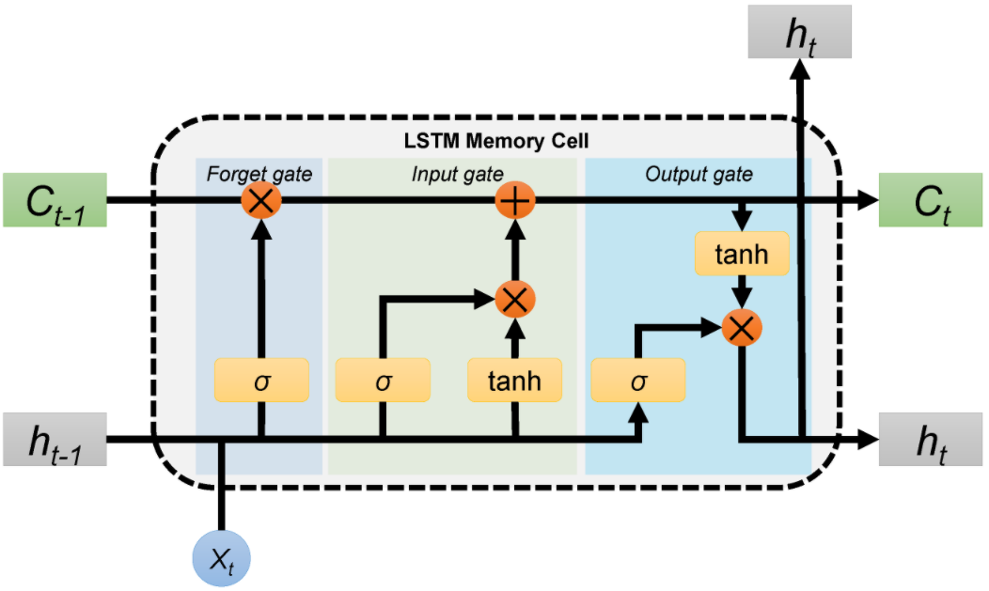

This flowchart provides an overview of the process, starting from data collection and preprocessing, moving through feature engineering, model selection and training, evaluation, post-processing, deployment, and finally, monitoring and maintenance. Each step is essential in building an effective fake news detection system using NLP.

BUDGET AND RESOURCE

Creating a budget for fake news detection using Natural Language Processing (NLP) involves several factors, including technology, data acquisition, human resources, and ongoing operational costs. Here's a breakdown of potential costs:

Technology and Infrastructure:

NLP Tools and Software Licenses: Cost for obtaining or subscribing to NLP frameworks, libraries, and tools (e.g., spaCy, NLTK, TensorFlow, PyTorch).

Cloud Computing Services: Expenses for using cloud platforms like AWS, Azure, or Google Cloud for processing and storing data.

Hardware: Cost for computing hardware if opting for on-premises infrastructure.

Data Acquisition and Preparation:

Data Collection: Expenses for acquiring a diverse dataset of fake and genuine news articles for training and testing the NLP models.

Data Cleaning and Annotation: Costs associated with cleaning, annotating, and preparing the data for training models.

Model Development and Training:

Development and Programming: Cost of hiring developers and data scientists to create and train NLP models for fake news detection.

Model Training Infrastructure: Additional cloud computing costs for training the NLP models.

Human Resources:

Data Scientists and Machine Learning Engineers: Salaries and benefits for professionals responsible for developing and refining the NLP models.

Data Labeling and Annotation: Costs associated with hiring annotators to label data for training the models.

Ongoing Operational Costs:

Model Maintenance and Updates: Ongoing costs for maintaining, updating, and improving the NLP models to keep them effective against evolving fake news tactics.

Monitoring and Evaluation: Resources for continuously monitoring the model's performance and making necessary adjustments.

Validation and Testing:

Cross-validation and Testing Infrastructure: Costs associated with testing and validating the models for accuracy, precision, recall, and other performance metrics.

Legal and Compliance:

Compliance Costs: Expenses for ensuring compliance with legal and ethical guidelines regarding data usage and privacy.

Contingency and Miscellaneous:

Contingency Budget: Allocated budget for unforeseen expenses or adjustments needed during the project.

Miscellaneous Expenses: Other potential costs not covered above.

It's challenging to provide precise budget estimates without specific project requirements and scale. The budget could range from a few thousand to several hundred thousand dollars, depending on the complexity of the project, the scale of deployment, and the accuracy required for the fake news detection system. It's advisable to consult with experts in the field and conduct a thorough analysis to arrive at an accurate budget for your project.

TEAM MEMBERS:

1.C.K. AKSHAYA PRATHIKSHA

2.S.SONIA

3.A.DIVYA

4.KUPPAIAH PAVITHRA

# FAKE NEWS DETECTION USING NPL -ARTIFICIAL INTELLEGENCE

PYTHON CODE:

python

import pandas as pd

from sklearn.model_selection import train_test_split

from sklearn.feature_extraction.text import CountVectorizer

from sklearn.naive_bayes import MultinomialNB

from sklearn.metrics import accuracy_score, classification_report

import nltk

from nltk.corpus import stopwords

# Download the NLTK stopwords dataset

nltk.download('stopwords')

# Load the dataset (you need to have a labeled dataset with 'text' and 'label' columns)

# For simplicity, let's assume you have a CSV file with 'text' and 'label' columns.

# Replace 'your_dataset.csv' with your actual dataset file.

df = pd.read_csv('your_dataset.csv')

# Data preprocessing

df.dropna(inplace=True) # Drop any rows with missing values

df.reset_index(drop=True, inplace=True)

# Text preprocessing: removing stopwords and converting to lowercase

stop_words = set(stopwords.words('english'))

df['text'] = df['text'].apply(lambda x: ' '.join([word.lower() for word in x.split() if word.lower() not in stop_words]))

# Split the dataset into training and testing sets

X = df['text']

y = df['label'] # Assuming 0 for fake news and 1 for real news

X_train, X_test, y_train, y_test = train_test_split(X, y, test_size=0.2, random_state=42)

# Feature extraction using CountVectorizer

vectorizer = CountVectorizer()

X_train_vectorized = vectorizer.fit_transform(X_train)

X_test_vectorized = vectorizer.transform(X_test)

# Train a classifier (Multinomial Naive Bayes in this example)

clf = MultinomialNB()

clf.fit(X_train_vectorized, y_train)

# Predictions

y_pred = clf.predict(X_test_vectorized)

# Evaluate the model

accuracy = accuracy_score(y_test, y_pred)

print("Accuracy:", accuracy)

# Print classification report

print("Classification Report:")

print(classification_report(y_test, y_pred))

TEAM MEMBERS:

1.C.K.AKSHAYA PRATHIKSHA

S.SONIA

3.KUPPAIAH PAVITHRA

4.A.DIVYA

# FAKE NEWS DETECTION USING NPL

CIRCUIT DIAGRAM:

The overall budget required for a fake news detection project using Natural Language Processing (NLP) can vary widely depending on several factors, including the scale of the project, complexity of the models, data collection, infrastructure, expertise, and other associated costs. Here are some cost factors to consider:

1. Data Collection and Annotation:

- Cost to procure a diverse and substantial dataset of labeled news articles, which may involve licensing fees or data acquisition costs.

2. Infrastructure and Computing Resources:

- Cost of computing resources (e.g., cloud servers, GPUs) required for model training, testing, and deployment.

3. Software and Tools:

- Licensing or subscription fees for NLP libraries, tools, and platforms that facilitate data preprocessing, model development, and evaluation.

4. Development and Modeling:

- Cost of hiring NLP experts, data scientists, and machine learning engineers to develop and fine-tune the models.

5. Model Evaluation and Testing:

- Cost of validating and evaluating the models, which may include costs for annotation, validation datasets, and benchmarking.

6. Post-Processing and Integration:

- Costs associated with refining model predictions, integrating the model into an application or platform, and ensuring smooth functionality.

7. Deployment and Maintenance:

- Costs for deploying the model (e.g., web application, API) and ongoing maintenance, updates, and bug fixes.

8. training and Education:

- Cost of training team members on NLP techniques, tools, and technologies to ensure a skilled workforce.

9. Miscellaneous:

- Miscellaneous costs such as legal, compliance, marketing, and project management.

It's challenging to provide an exact budget without specific project details and requirements. A small-scale project might have a budget in the thousands to tens of thousands of dollars, while larger, more comprehensive projects could range from tens of thousands to hundreds of thousands of dollars or more.

To determine a precise budget, it's important to conduct a detailed analysis of your project requirements, assess the scope, and consult with experts in the field to estimate costs accurately. Additionally, consider exploring grant opportunities, partnerships, or collaborations to help offset costs and access additional resources.

Detecting fake news using Natural Language Processing (NLP) involves a combination of data preprocessing, feature engineering, and machine learning algorithms. Here's a step-by-step algorithm for fake news detection using NLP:

1. Data Collection and Preprocessing:

- Collect a dataset of labeled news articles, categorizing them as "fake" or "genuine."

- Preprocess the text data by removing special characters, HTML tags, and irrelevant information. Tokenize the text into words or subwords.

- Apply stopword removal and perform lemmatization or stemming to reduce words to their root forms.

2. Feature Engineering:

Convert the preprocessed text into numerical features. Common methods include:

-TF-IDF (Term Frequency-Inverse Document Frequency):** Measures the importance of a word in a document relative to its frequency in the entire dataset.

-Word Embeddings:Represent words as dense vectors in a continuous space (e.g., Word2Vec, GloVe).

- Additional Features: Consider adding sentiment scores, named entity recognition, or linguistic features.

3. Model Selection:

- Choose a suitable machine learning or deep learning algorithm for classification. Common choices include:

-Logistic Regression

- Support Vector Machines (SVM)

- Multinomial Naive Bayes

- Random Forest

- Deep Learning Models (e.g., LSTM, BERT)

4. Model Training:

- Split the dataset into training and testing sets (e.g., 80% for training, 20% for testing).

- Train the selected model(s) using the preprocessed data and numerical features.

5. Model Evaluation:

- Evaluate the model's performance using appropriate metrics such as accuracy, precision, recall, F1-score, and ROC-AUC.

- Analyze confusion matrices to understand false positives and false negatives.

6. Post-Processing and Refinement:

- Apply post-processing techniques to further refine predictions. This may involve adjusting prediction thresholds or using ensemble methods to combine model outputs.

7. Deployment:

- Deploy the model using a web application, API, or another suitable platform.

- Provide a user-friendly interface for users to input news articles and receive predictions regarding their authenticity.

8. Monitoring and Maintenance:

- Monitor the model's performance in real-time and gather user feedback.

- Periodically retrain the model with updated data and perform necessary maintenance and updates.

9. Education and Awareness:

- Educate users about the limitations of the model and the importance of critical thinking when evaluating news sources.

This algorithm provides a structured framework for building a fake news detection system using NLP. However, the specific implementation details and choices of algorithms can vary based on the dataset and project requirements. Experimentation, fine-tuning, and continuous improvement are key to developing an effective fake news detection solution.